**Lab 1-1**

**1.3**

**1.4**

**e.**

**f.**

**g.**

**1.5**

**c.**

**g.** 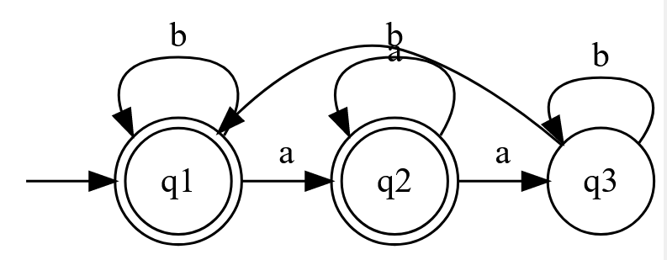

**1.6**

**b.**

**f.**

